18th INTERNATIONAL BIOLOGY OLYMPIAD
JULY 15 - 22, 2007



THEORY EXAMINATION # 2

Total marks possible: 65

Time allowed: 20 minutes

WRITE YOUR 4-DIGIT STUDENT NUMBER IN THE BOX BELOW

STUDENT CODE

GENERAL INSTRUCTIONS

Check that you have the correct examination paper and an answer sheet.

BE SURE TO RECORD ALL YOUR ANSWERS ON THE ANSWER SHEET

WHEN YOU HAVE FINISHED THE EXAM, PLACE YOUR ANSWER SHEET INSIDE YOUR QUESTION PAPER AND HAND BOTH TO THE INVIGILATOR BEFORE LEAVING THE EXAM ROOM.

REMEMBER TO WRITE YOUR 4-DIGIT STUDENT CODE ON THE FRONT PAGE OF THE QUESTION PAPER.

Read each question carefully before attempting it.

IMPORTANT

➢ Use the answer sheet provided to record your answers.

➢ Ensure that your name and student code is PRINTED in the top margin of the front page of the answer sheet. The markers will enter this information in the correct places on the reverse side of the answer sheet.

➢ Use only the HB pencil provided to mark the answer sheet. Completely fill in the circle.

A B C D E
This is the correct way: o  o o o

➢ DO NOT USE AN X OR ANY OTHER SYMBOL TO MARK YOUR ANSWER.

➢ If you want to change your answer, use the eraser to completely erase your correct response and fill ion the new circle you require.

➢ There is only one correct answer to each question.

➢ Each question is worth one mark Marks will not be deducted for incorrect answers.

Question 1. The diagram below shows a section through a mammalian ovary.

Question 1. The diagram below shows a section through a mammalian ovary.

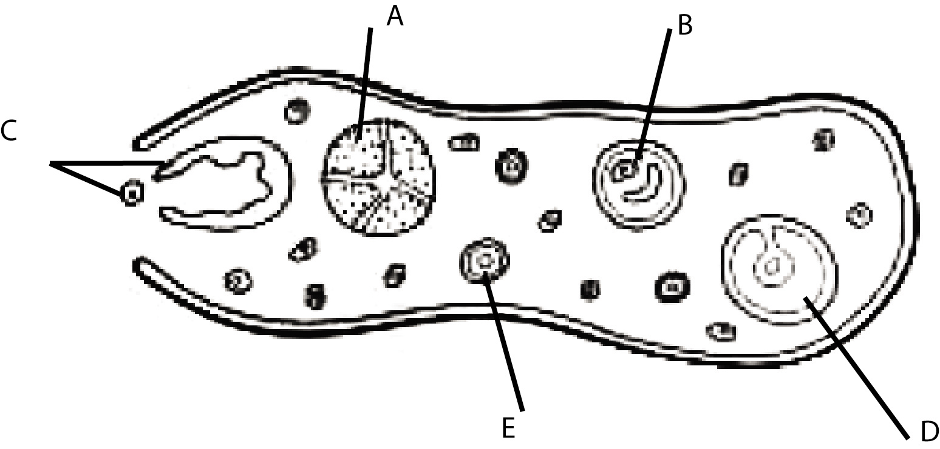

Which one of the following is the correct sequence of the development of the structures indicated by the letters A to E?

A. A, C, D, B, E
B. A, B, D, C, E
C. C, B, D, A, E
D. D, B, C, A, E
E. E, B, D, C, A

Question 2. Oogenesis differs substantially from spermatogenesis. Which of the following statements concerning oogenesis is INCORRECT?

A. Cytokinesis is unequal during the meiotic divisions
B. The sequence from secondary oocyte to ovum is interrupted by a relatively long rest period
C. The first meiotic division is not completed unless the egg is reactivated by a hormone
D. A mature ovum has not completed its second meiotic division
E. The number of potential gametes is, by and large, established at birth

Questions 3 – 7. Examine the figure below:

Hormone Levels during the Human Female Reproductive Cycle

A
B
C
D
In these graphs, the
BLACK line represents the level of hormone A.
RED line represents the level of hormone B.
BLUE line represents the level of hormone C.
GREEN line represents the level of hormone D.
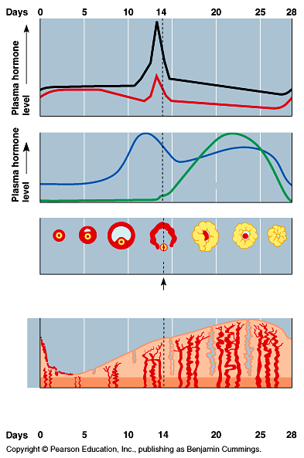

Question 3. Which of the following correctly lists the hormones in order from A to D?

A. estrogen, progesterone, LH, FSH
B. estrogen, FSH, progesterone, LH
C. FSH, LH, progesterone, estrogen
D. LH, estrogen, FSH, progesterone
E. LH, FSH, estrogen, progesterone

Question 4. Which of the following statements is INCORRECT?

A. An increase in hormone B causes a decrease in hormones C and D
B. A steep rise in hormone C stimulates the production of hormones A and B.
C. A small increase in hormone C inhibits the production of hormones A and B.
D. A rise in hormones C and D inhibits the secretion of hormones A and B

Question 5. Ovulation is triggered by a peak in the hormone whose level is shown by the

A. Line A
B. Line B
C. Line C
D. Line D

Question 6. Hormones A and B are secreted by the

A. uterine wall
B. ovary
C. hypothalamus
D. anterior pituitary

Question 7. Hormones C and D are secreted by the

A. uterine wall
B. ovary
C. hypothalamus
D. anterior pituitary

Question 8. It is assumed that plants replace their very thin roots (<2mm) several times per year resulting in a high amount of dead plant material in the soil. One hypothesis predicts that most of the CO₂ produced in the soil originates from microorganisms feeding on dead plant material. To which trophic level do these microorganisms belong?

A. . Primary producers
B. Secondary producers
C. Decomposers
D. First order consumers
E. Second order consumers

Question 9. Joan and Claude come to you seeking genetic counseling. Claude was married before, and he and his first wife had a child with cystic fibrosis, a homozygous recessive condition. A brother of Joan’s died of cystic fibrosis and Joan has never been tested for the gene. If they marry, what is the probability that Joan and Claude will have a son that WILL NOT be a carrier for or have cystic fibrosis?
- A. 1/12
- B. 1/8
- C. 1/6
- D. 1/4
- E. 1/2

Question 10. Chromosomal crossing over occurs in which of the following stages of cell division?

A. Prophase of mitosis.
B. Metaphase of mitosis.
C. Prophase I of meiosis.
D. Metaphase II of meiosis.
E. Telophase I of meiosis.

Question 11. A man whose blood group is Type A has two boys. The plasma of one of the boys agglutinates the red cells of his father, but the plasma from the other son does not. Which combination of the following statements.is correct?

I. The father must be heterozygous for the A blood type allele.
II. The mother of the son that agglutinates his father’s blood can be type AB.
III. The boy that agglutinates could have type O blood.
IV. The mother of the son that agglutinates must possess a type O allele.
V. The boy that doesn´t cause agglutination can be type AB.

A. I, II, V
B. I, III, V
C. I, IV, V
D. II, III, IV
E. II, IV, V

Question 12. In peas, the allele for smooth seed coat (S) is dominant to wrinkled (s), Tall plant (T) is dominant to short (t) and yellow coloured seed (Y) is dominant to green (y).

A plant with the genotype SsTtyy was test crossed and 145 progeny survived to maturity. Approximately how many of these progeny are expected to be tall plants with green wrinkled seeds?

A. 9
B. 18
C. 36
D. 72

Question 13. B chromosomes are additional chromosomes possessed by some, but not all, individuals in a population. Which combination of statements is correct?

I. They occur only in plants.
II. While they are common in plants, they occur also in fungi, insects and animals.
III. They arise from normal chromosomes by fragmentation.
IV. They are normal, but short, chromosomes..
V. In plants they are associated with reduced viability.

A. I, III and V
B. I, IV and V
C. II, III and V
D. II, IV and V

Question 14. Often the frequency of a particular deleterious allele is very different in neighbouring countries. For example, the frequency of the allele causing cystic fibrosis is 0.02 in Germany and 0.006 in Switzerland. Such a difference in allele frequencies between two close populations is probably the result of

A. The occurrence of the founder effect in an earlier generation
B. More effective repair of DNA damage caused by mutation
C. Selective advantage of the allele in one population but not the other
D. Recurring migration between the populations
E. Non-random mating.

Question 15. The coefficient of relatedness is a theoretical value determined by the number of genes that would be the same between two organisms. Thus, since a parent gives half its genes to an offspring, the parent and offspring would have a coefficient of relatedness of 0.5.

The diagram below shows the relationships between some bees. What is the coefficient of relatedness between II-2 and II-3; and between II-2 and III-1?

1 2 3

I

II

III

ANSWER | Between II-2 and II-3 | Between II-2 and III-1
A. | 0.50 | 0.50
B. | 0.75 | 0.50
C. | 0.00 | 1.00
D. | 0.25 | 1.00
E. | 0.50 | 0.75

Question 16. Collenchyma and sclerenchyma are plant support tissues. Which combination of the following statements correctly differentiates these two types of plant tissue?

I. Collenchyma is a plastic tissue that occurs only in Dicotyledons; sclerenchyma is an elastic tissue that is found in both Monocotyledons and Dicotyledons.
II. Collenchyma cells are developed in young organs during growth; sclerenchyma cells occur in organs that have concluded their longitudinal growth.
III. Ccollenchyma and sclerenchyma arise from the same cell type.
IV. Collenchyma cells have primary walls only while sclerenchyma cells have secondary walls.
V. Collenchyma originates from the protoderm; sclerenchyma is formed by the procambium.

A. I, II, III.
B. I, II, IV
C. III, IV, V
D.IV, V

Question 17. The following figure shows the carbon fixation reactions during hotosynthesis in a typical C4 plant :

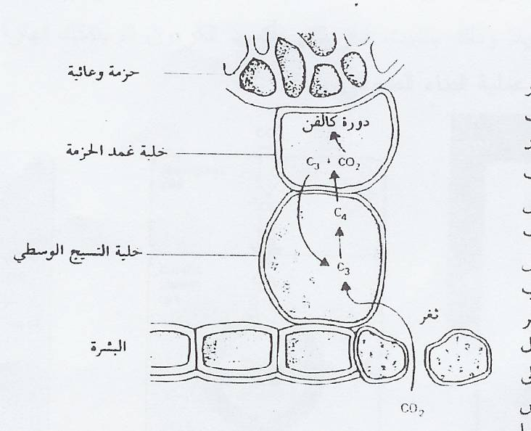
Vascular bundle
CELL 1
CELL 2
epidermis
Which of the following answers indicate the dominant carbon fixation enzyme in each of the two cells?

Answer | Cell 1 | Cell 2
A. | Malate dehydrogenase | Sucrose synthase
B. | PEPCase | Rubisco
C | Rubisco | PEPCase
D. | Aspartate aminotransferase | Malate dehydrogenase
E. | Malic enzyme | Pyruvate dehydrogenase

Question 18. Suppose that an illuminated suspension of Chlorella (a photosynthetic alga) was actively carrying out photosynthesis when the light was suddenly switched off. How would the levels of 3-phosphoglycerate and ribulose 1,5-bisphosphate change during the next minute?

A. The concentration of 3-phosphoglycerate would increase and that of ribulose 1,5- bisphoshate would increase.
B. The concentration of 3-phosphoglycerate would increase; the concentration of ribulose
1,5-bisphoshate would decrease.
C. The concentration of 3-phosphoglycerate would decrease; the concentration of ribulose 1,5-bisphoshate would increase.
D. The concentration of 3-phosphoglycerate would decrease; the concentration of ribulose 1,5-bisphoshate would decrease.
E. The concentration of 3-phosphoglycerate would remain the same; the concentration of ribulose 1,5-bisphoshate would decrease.

Question 19. Which of the following statements shows the difference between the reaction sites
of photosystem I and II ?

A. Chlorophyll a is found in photosystem I; chlorophyll b is found in photosystem II.
B. Each preferentially absorbs slightly different wavelengths of light.
C One is located in the thylakoid membrane; the other occurs in the stroma.
D. Only photosystem I is found in the thylakoid membranes.
E. None of these statements are correct.

Question 20. You are a biotechnologist designing novel enzymes that are regulated by phosphorylation. Which amino acid residues shown below would you most likely use at the regulatory site?

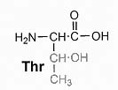
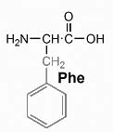
I. II. III.
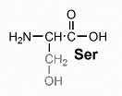 . .

.
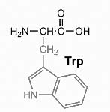
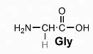
IV. V.
.

A. I, II, III
B.. I, II, IV
C. I, III, IV
D. II, IV, V
E. III, IV, V

Question 20. A biologist has discovered two new species of micro-organisms. Micro-organism A was isolated from a hot spring whereas micro-organism B was obtained from a tropical forest. DNA was isolated from both organisms and an analysis of the melting profile of each DNA sample was carried out. The melting temperature (Tm) was 80 °C for DNA from micro-organism A, and 70 °C for DNA from micro-organism B.

Which statement best describes the reason for this difference in values?

A. DNA of micro-organism A has higher A+T content
B. DNA of micro-organism A has higher G+A content
C. DNA of micro-organism A has higher G+C content
D. DNA of micro-organism A has higher T+G content
E. DNA of micro-organism A has a higher proportion of TGA codons

Question 21. Which of the following cofactors is not redox active?

I. Coenzyme A
II.. Flavin coenzyme
III.. NADH
IV. Vitamin C

A. I
B. II
C. III
D. IV
E. I, III

Questions 22-23. Two cells have the following characteristics:

Characteristic | Cell I | Cell II
Cell wall | Present | Present
Ribosomes | Present | Present
Nucleus | Absent | Present
Ability to photosynthesize | Present | Absent
Cell respiration | Present | Present

Question 22. From the characteristics presented in the table, which statement is correct?

A. Cell I is more complex in its organization than cell II
B. Cell I is a prokaryote
C. The ancestors of cell II appeared earlier in the fossil record than the ancestors of cell I
D. Cell II does not have a cell membrane
E. Both groups of cells are from plants

Question 23. Cell II is probably a

A. plant cell
B. eubacterium
C. archaebacterium
D. animal cell
E. cyanobacterium

Question 24. Suppose Species B disappears from an ecosystem in which the interrelationship among the component species can be described by the ecological pyramid below.
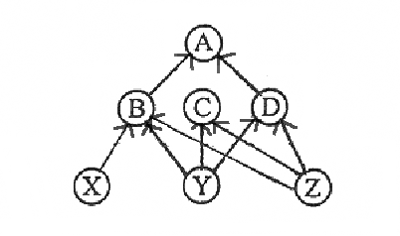
Which of the following consequences of its elimination will result?:

A. Species X loses its only prey.
B. Species A loses its only prey.
C. Species D benefits because it is most distant from Species B.
D. Species C benefits because the competition between species B and species C is reduced.
E. The disappearance of species B has no effect on species C or species D.

Question 25. You have been asked by an international organization to initiate a biodiversity conservation project on a tropical island off the south coast of Java, and far from any large continental land. For this purpose, you must identify from three islands the island that has the highest number of species.

The following information is provided:

Island Name | Size/Area | Distance from Java
Boa | 418 km² | 220 km
Ibo | 500 km² | 800 km
Bio | 420 km² | 450 km

Which of the following statements describes your decision?
A. . Bio Island
B. Boa Island
C. Ibo Island
D. Either Boa Island or Bio Island
E. Insufficient information is provided to allow you to make a decision.

Question 26. Marine bony fishes have much lower internal osmotic concentration than the seawater around them. Which of the following statements DOES NOT EXPLAIN the osmotic regulation of marine bony fishes:

A. They loose water and gain salt
B. They drink seawater
C. They actively absorb sodium chloride across gills
D. They absorb sodium chloride from stomach
E. They absorb water from stomach

Question 27. The best description of the relationships between fundamental niches (FN) and realized niches (RN) of two competing species that coexist is:

A. FN_{A} = RN_{A}; FN_{B} = RN_{B}
B. FN_{A} > RN_{A}; FN_{B} = RN_{B}
C. FN_{A} < RN_{A}; FN_{B} < RN_{B}
D. FN_{A} > RN_{A}; FN_{B} > RN_{B}
E. FN_{A} = RN_{A}; FN_{S} > RN_{S}

Question 27. Use the information given in Figures 1 and 2 to answer this question.

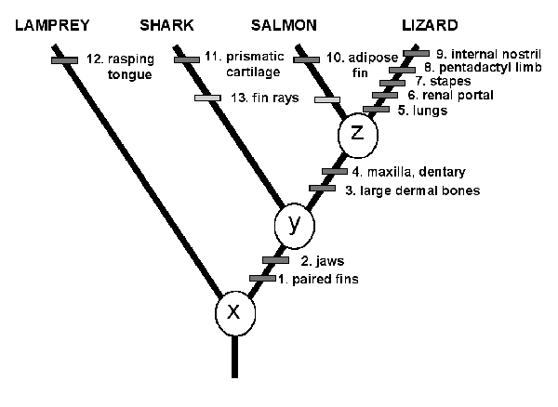

Figure 1. An example of a phylogeny showing characters by which taxa are recognised. Characters 1 – 4 are synapomorphies, 5 – 12 are autapomorphies and 13 is an attribute seen in the salmon and the shark.

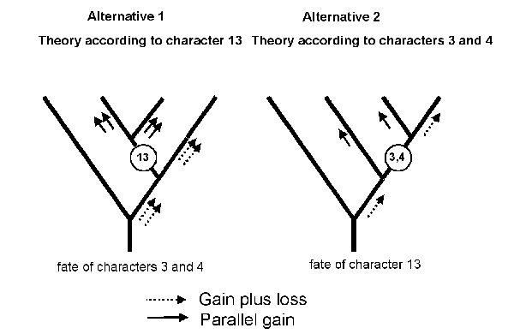

Figure 2. Two possible ways to organize the data from Figure 1.

Which of the following statements best describes the information presented in Figures 1 and 2?

A. Alternative 2 shows more parsimony than does Alternative 1.
B. The Lamprey and the Lizard are the oldest because they have the longest line.
C. The four groups shown in Figure 1 are equally related because they are all at the same horizontal level.
D. X, Y and Z are characteristics common to all groups.
E. The Lamprey is more closely related to the Shark than to the Salmon or the Lizard.

Question 28 . A woman visits her doctor after noticing several changes in her body over a period of 6 (six) months. She has noticed weight loss, intolerance to temperature variations, irregular menstrual cycles, insomnia, and general weakness. Based on these symptoms, you would expect the doctor to test her for:

A. Diabetes mellitus
B. Grave’s disease
C. Hashimoto’s disease
D. hypoglycemia

Question 29. Endocrine glands that compose the endocrine system

A. Produce hormones that are secreted into the digestive tract
B. Release hormones into the bloodstream
C. Release hormones as rapidly as nerve impulses are transmitted
D. Are present only in humans

Question 30. Long corolla length in tobacco is inherited as a recessive monogenic characteristic. If in a natural population 49% of the plants have a long corolla, what is the probability that the result of test crossing plants with a short corolla from this population in F₁ will have uniform progeny?

А. 100%
B. 50%
C. 30%
D. 18%
E. 0%

Question 31. From an evolutionary viewpoint, which of the five following individuals is the most fit?
А. A child who does not become infected with any of the usual childhood diseases, such as measles or chicken pox.
B. A woman of 40 with seven adult offspring
C. A woman of 80 who has one adult offspring
D. A 100-year old man with no offspring
E. A childless man who can run a mile in less than five minutes

Question 32.. A study of a grass population growing in an area of irregular rainfall found that plants with alleles for curled leaves reproduced better in dry years, whereas plants with alleles for flat leaves reproduced better in wet years. Curled and flat leaves are controlled by different alleles at the same gene locus.

This situation tends to

A. cause genetic drift in the grass population
B. cause gene flow in the grass population
C. lead to directional selection in the grass population
D. preserve variability in the grass population
E. lead to uniformity in the grass population

Question 33. The cohesion-tension (C-T) theory of sap ascent states that in plants sap is transported against gravity by solar-powered bulk flow through the xylem vessels or chains of tracheids. Which of the following statements correctly describes the main factors affecting this bulk flow?

A. Hydrogen bonds within the water, hydrogen bonding to the hydrophilic walls of the xylem cells, and the gradient of water potential (ψ).
B. The gradient of the pressure potential (ψ_{p}), and solute concentration
C. The gradient of water potential (ψ), hydrogen bonds within the water and solute concentration.
D. Hydrogen bonds within the water, hydrogen bonding to the hydrophilic walls of the xylem cells, and the gradient of pressure potential (ψ_{p}).

Questions 34 - 36. Plants maintain most IAA in conjugated forms, which complicates IAA quantification.

Question 34. These forms can exist in forms such as

A. AA-amino acid conjugates
B. IAA-hydrolase conjugates
C. IAA-glycerol conjugates
D. IAA-peroxide conjugates

Question 35. Before analysis in order to measure total IAA in a particular tissue, these conjugates must be

A. dehydrated
B. dehydrogenized
C. hydrolyzed
D synthesized

Question 36. Therefore free IAA, thought to be the active form of the hormone, is measured

A. in the same sample without enzymes
B. in the same sample with enzymes
C. in a parallel sample without enzymes
D. in a parallel sample with enzymes

Question 37. You find a mutant bacterium that synthesizes lactose-digesting enzymes whether or not lactose is present. Which of the following statements or combination of statements might explain this?

I. The operator gene has mutated causing it to no longer recognise the repressor.
II. The gene that codes for the repressor has mutated and the repressor is no longer effective.
III. The gene or genes that code for the lactose-digesting enzymes have mutated.

A. I
B. II
C. I, II
D. I, III
E. I, II, III

Question 38. What mechanism is responsible for the acidification of the lysosome?

A. A lysosome fuses with acidic vesicle derived from Golgi aparatus
B A pump transports protons from the cytosol into the lysosome
C. A pump transports protons from the lysosomal lumen to the cytosol
D. A lysosome fuses with acidic endocytosed material
E. A pump transports OH⁻ ions from the cytosol to the lysosomal lumen

Question 39. Active transport is defined as the transport of an ion or other compound across the cell membrane requiring ATP as an immediate energy source. Which of the following is an example of active transport?

A. K⁺ through a voltage-gated K⁺ channel
B. Ca²⁺ through a voltage-gated ion channel
C. Na⁺ through ligand-gated ion channel
D. 3 Na⁺ in exchange for 2 K⁺ across the plasmalemma
E. All of the above

Question 40. The transport of glucose into the red blood cell is accomplished by

A. simple diffusion through the lipid bilayer
B. a Na⁺ - K⁺ ATPase
C. esterifying the glucose to phosphatidate
D. first converting glucose into lactose
E. diffusion through a glucose transporter

Question 41. Sow-bugs (Porcellio sp.) are one of the few crustacean groups that have successfully invaded terrestrial habitats. Which of these statements is INCORRECT?

A. They live in dry conditions.
B. They must live in moist conditions.
C. Their abdominal appendages bear gills.
D. They do not have an efficient cuticular covering to conserve water.

Question 42. Hormones are essential to maintaining homeostasis mainly because

A. they catalyze specific chemical reactions in brain cells.
B the body requires them for digesting food.
C. they cause specific responses in specific targets.
D they act faster than nerve impulses.

Question 43. Compared to nerve impulses, hormones are generally

A. released more slowly and have longer lasting effects.
B. released faster and have longer lasting effects.
C. release more slowly and have effects of a shorter duration.
D. released faster and have effects of shorter duration.

Question 44. Someone who has suffered damage to the pancreas might

A. have trouble walking in a straight line.
B. be unable to remember a recent event.
C. have periods of very low energy.
D. have trouble squeezing an object with either hand.

Question 45. The hypothalamus has a dual function in that it

A. sends nerve impulses and also makes hormones.
B. is both a nervous and an excretory organ.
C. belongs to both the nervous and circulatory systems.
D. is found connected to both kidneys.

Questions 46 - 47. Ten grams of plant material were homogenized in 50 ml buffer and the homogenate was centrifuged. Protein from 10 ml of the supernatant was precipitated by addition of ammonium sulphate and the protein precipitated was collected by centrifugation and re-suspended in 1 ml of buffer. The re-suspended protein was diluted 10 times for protein determination.

Question 46. The amount of protein in 1 ml of the diluted sample was 0.4 mg. What is the total amount of protein recovered from 10 ml of the supernatant?

A. 2 mg
B. 4 mg
C. 6 mg
D. 8 mg

Question 47. What is the amount of protein extracted from 100 g tissue?

A. 0.2 g
B. 0.4 g
C. 0.6 g
D. 0.8 g

Question 48. Prion diseases are characterized by:
A cellular DNA damage.
B. misfolded proteins that are much more soluble than the regular form of the protein.
C. a misfolded protein that is prone to aggregation and is very stable.
D. abnormal enzyme activity.
E. protein chaperones in cells.

Question 49. Why are some proteinases synthesized as inactive precursors known as zymogens?

A. Because they don’t degrade a cell’s starch supply.
B. Zymogens have a higher degree of substrate specificity than most enzymes.
C. Zymogen synthesis ensures that proteinase activity is kept to a minimum inside the cell where they are synthesised.
D. Zymogens are better at interconverting energy than regular enzymes.
E. Zymogens are more resistant to protein denaturation than the regular proteinase.

Question 50. Negative feedback is a process that

A. always reduces the amount of a hormone present in the blood.
B. keeps conditions near their normal state.
C. lowers the body temperature below normal.
D. none of the above are correct.

Question 51. What is the role of the “second messenger” in hormone action?

A. it signals a cell to secrete a hormone.
B. it informs a gland as to whether its hormones are having an effect.
C. it relays a hormone’s message inside a target cell.
D. it carries a hormone while it is in the blood.

Question 52. It takes much longer for sex hormones and other steroids to produce their effect that it takes nonsteroid hormones. Why?

A. Steroids are bigger, slower molecules.
B. Steroids usually must be carried longer distances by the blood.
C. Steroids cause target cells to make new proteins, which take time.
D. Steroids relay their message via a second messenger.

Questions 53 – 55. To test the origin of CO₂ available in the soil, two experiments were conducted on trees in a Pinus forest.

Question 53. In the first experiment, a 20 cm-wide strip of bark around the stem was removed from trees mid-way between the ground and the lowest branch.

Which of the following statements correctly describes the effect of this treatment on the trees?

A. Transpiration will cease. As a result, the tree will lose all its needles.
B. Transport of auxin in the xylem is prevented. This will cause increased auxin concentration in the roots and root growth will be stimulated.
C. Phloem transport is prevented causing the roots to become deficient in nitrogen.
D. Transport of sugars to the roots ceases and the roots will die.
E. Transport of potassium and calcium from the roots to the needles will cease.

Question 54. In the second experiment, the amount of CO₂ released from the soil at the base of trees was measured on several days during the growing period. The bark-removal experiment was repeated on a total of 9 trees, three trees per teament. In the first treatment, the bark was removed in early June (white triangles); in the second treatment, the bark was removed in late August (white squares); the third treament was the control treatment where the bark was not removed (black circles).

The data from this experiment is shown in the following graph. The black arrows indicate the time of bark removal.
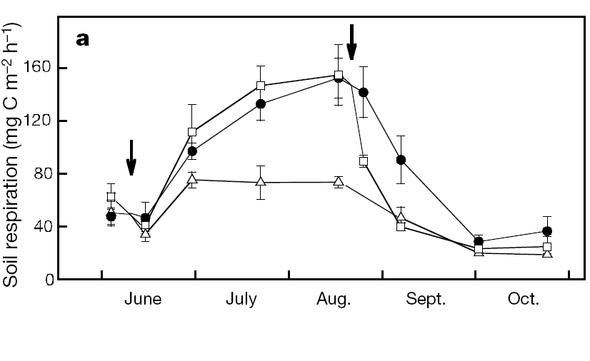

Which combination of the following statements best describe the results of this experiment?

I. The variability of the different treatments overlap and any effect of bark removal is due to chance.
II. The production of CO₂ in the soil shows seasonal variation.
III. Bark removal in June had a much smaller effect on the total CO₂ production in the soil during the whole season than bark removal in August.
IV. The decrease in the CO₂ production in the soil in the treatments where bark was removed cannot be explained by seasonal variations alone.
V. The production of CO₂ in the soil is always smaller for trees with bark removed than for undamaged trees.

A. Only I, II and V
B. Only I , II and IV
C. Only II, IV and V
D. Only II, III and IV
E. Only I, III and V

Question 55. Which of the following statements is a valid conclusion for the results of the second experiment?

A. Most CO₂ produced in the soil is due to the decomposition of dead roots.
B. Most CO₂ produced in the soil is due to cellular respiration of root cells.
C. The amount of CO₂ produced in the soil is not influenced by photosynthesis.
D. When most of the roots die, the production of CO₂ in the soil is greatest.
E. The amount of CO₂ produced in the soil depends on the soil temperature.

Questions 56 - 57. Below are six floral diagrams, labelled A to F.
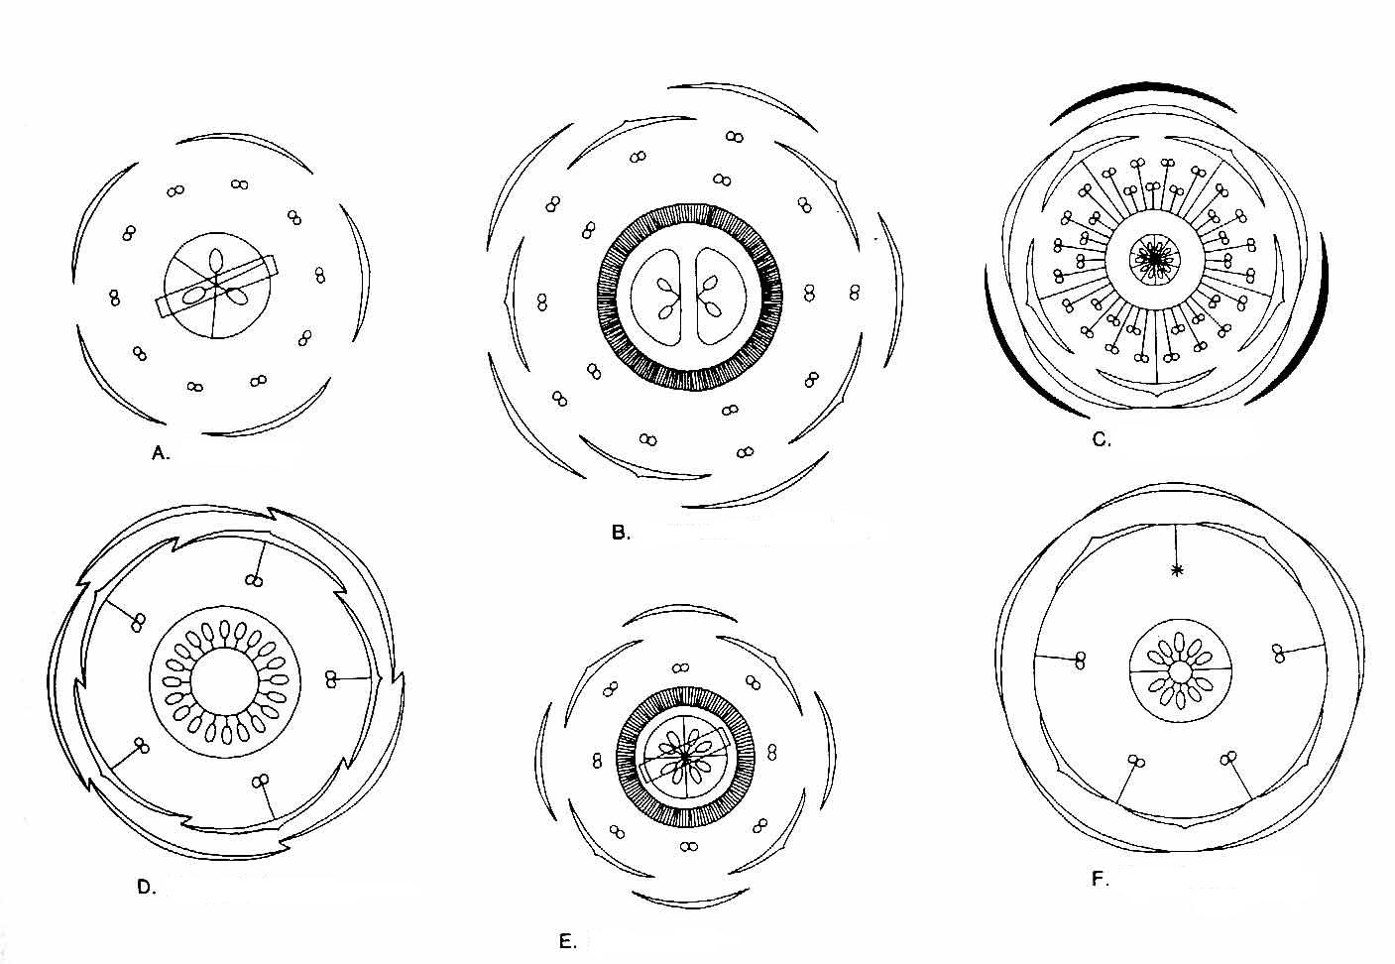
Question 56. From the following, choose the combination in which the floral diagram is associated with the correct family.

A. A = Brassicaceae
B. B = Fabaceae
C. C = Liliaceae
D. D = Malvaceae
E. E = Rosaceae

Question 57. In which floral diagram do the all the floral characteristics listed below occur?

 Zygomorphic flower, fused sepals
 Axile placentation.
 Epipetalous stamen

A. B
B. C
C. D
D. E
E. F

Question 58. Students made cross-sections of leaves collected from two different oak trees. When they examined the sections under a microscope, they were surprised to see that the leaves were different.

The following diagrams show cross-sections of leaves from Oak tree 1 and Oak tree 2.

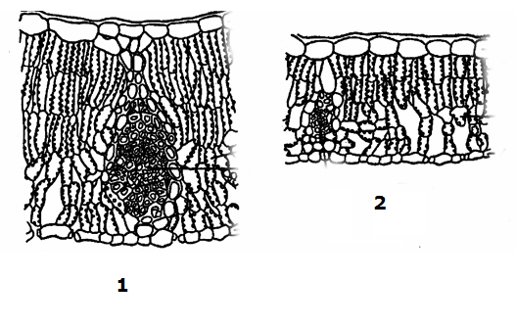

Which of the following statements best explains the difference in leaf structure that the students observed?

A. Oak tree 1 grows in a swampy area; Oak tree 2 grows in sandy soil.
B. Oak tree 1 is a young tree; Oak tree 2 is a mature tree.
C. Oak tree 1 grows in fertile soil; Oak tree 2 grows in poor soil.
D. Oak tree 1 is exposed to sun for most of the day; Oak tree 2 grows in a shaded area.
E. Oak tree 1 is infected by fungi, which induced the cell proliferation; Oak tree 2 was not infected.

Question 58. Cloning of a new DNA fragment into a circular plasmid/vector relies on:

A. Complementary base pairing
B. DNA ligase activity
C. The presence of the same restriction site in the insert and the vector
D. Selectable markers and autonomous replicating sequences
E. All of the above

Question 59. Below is a diagram representing cholesterol in the lipid bilayer.
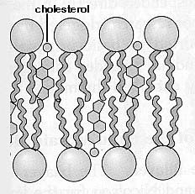

Cholesterol mixes with phospholipids in a cell membrane because cholesterol molecules are:

A. amphipathic
B. steroid derivatives
C. entirely hydrophobic
D. phospholipids derivatives
E. bound with glycoproteins

Question 60. Which of the following molecules can diffuse through the lipid bilayer without using a channel/transporter?

I.. O₂
II. glucose
III. steroid hormones
IV. K⁺
V. amino acids

A. I, III
B. I, IV
C. II, III, V
D. II, III, IV, V
E. All of the above.

Question 61. What is the net charge of aspartic acid when the pH of the solution in which it is prepared is the same as its pI value? Note the three pKa values of aspartic acid are as follows:
-COOH pKa = 2.1; -NH₃⁺ pKa = 9.8; R group pKa = 3.9

A. one net positive charge
B. two net positive charges
C. one net negative charge
D. two net negative charges
E. no net charge

Question 62. A quantitative amino acid analysis reveals that bovine serum albumin (BSA) contains 0.58% tryptophan residues by weight. The molecular mass of the tryptophan molecules is 204 daltons. The molecular mass of bovine serum albumin is known to be 66,000 daltons. What number of tryptophan residues is present in each BSA molecule?

A. 2
B. 3
C. 4
D. 5
E. 6

Question 63. What essential function does gastrulation perform for the developing embryo?

A. It gives form to the embryo.
B. It gives rise directly to basic tissue types of the embryo.
C. It gives rise to neural crest cells.
D. It gives rise directly to endocrine cells.
E. It gives rise directly to the trophectoderm.

Question 64. Which of the following is not true about the lymphatic system?

A. It helps maintain the volume and protein concentration of the blood.
B. It helps defend the body against infection.
C. It transports fats from digestive tract to circulatory system.
D. Lymph composition is similar to that of interstitial fluid.
E. Lymph drains directly into the excretory system.

Question 65. The most direct consequence on amphibian development upon removal of the grey crescent would be:

A. Inability to develop from the 2-cell stage to the 4-cell stage.
B. Inability to develop form the 4-cell stage to the 8-cell stage.
C. Inability to form a blastocoel.
D. Inability to form dorsal structures.
E. Inability to form ventral structures.

- THE END -

